🧭 Classification of Homophones
# Source: Chatgpt (GPT-4-turbo) at [8/1/2025]
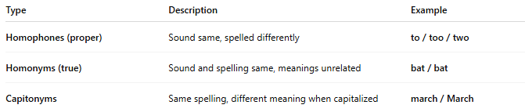
Type | Description | Example
Homophones (proper) | Sound same, spelled differently | to / too / two
Homonyms (true) | Sound and spelling same, meanings unrelated | bat / bat
Capitonyms | Same spelling, different meaning when capitalized | march / March

